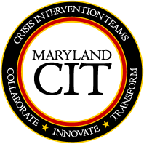

3rd Annual Maryland CIT Conference
The state CIT Coordinators in collaboration with the Maryland Department of Disabilities and NAMI present the 3rd Annual CIT Maryland Conference: Bringing Officer Wellness in Focus
Keynote Speaker – Lt. Marc Junkerman “Look How Far We’ve Come, A Celebration of Maryland CIT Communities”
Monday, May 6, 2019 8am – 4pm Annapolis, MD
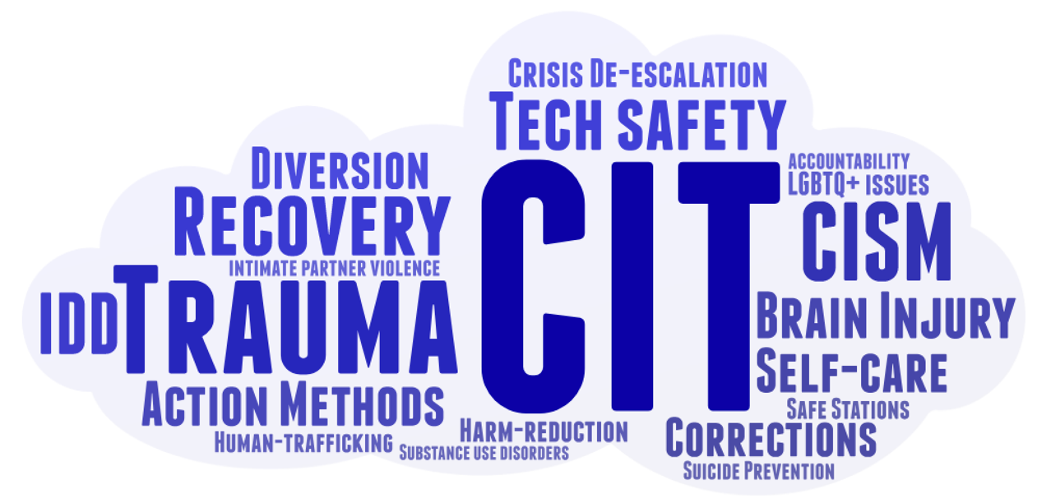
Double Tree by Hilton Annapolis 210 Holiday Court Annapolis, MD (410)224-3150 $89 Room Rates
Conference Fee $40 Breakfast and Lunch included Pre-Conference Networking Event 5/5/2019 from 5:30pm – 8:30pm
Registration Required. No walk-in. Registration deadline: April 19, 2019 Police & Corrections Training Credits pending
Conference Questions? Contact Veronica Dietz, LCSW-C at (443) 952-7532 or veronica.dietz@maryland.gov
To attend this year’s conference, please return registration with breakout session selection form and payment information attached. Payments may be made via mail, fax, or phone. Checks and credit card payments accepted.
Sponsored by the Maryland Behavioral Health Administration’s Office of Workforce Development and Training.
The Office of Workforce Development and Training is authorized by the Maryland Board of Professional Counselors and Therapists to sponsor continuing education programs for Category A CEU, the Maryland Board of Social Work Examiners to sponsor social work continuing education programs for 5 Category I CEU, the State Board of Examiners of Psychologists and the Maryland Association of Prevention Professionals & Advocates to sponsor continuing education programs for CEU. Participants must attend all hours of the training and submit an evaluation to receive a certificate. The Office of Workforce Development and Training maintains full responsibility for this program.

3rd Annual Maryland CIT Conference
Name: __________________________________________
Phone Number: ___________________________________
Email: ___________________________________________
Payment method (circle one): Credit Card Check
Please check one:
- I plan to attend the Pre-Conference Networking Event (5/5/2019 from 5:30pm – 8:30p)
- I will not be attending the Pre-Conference Networking Event
Breakout Session Selection
Session 1 Options (11:00am-12:15pm) choose one only
CIT Response to a Traumatic Event Action Methods at CCYSB: Responding to Family Crisis
Suicide Post-vention Response Someone’s Watching Me: Tech Safety in Internet Partner Violence
Justice and Recovery Advocates

Session 2 Options (1:15pm-2:30pm) choose one only
Interacting with Individuals living with Brain Injury: Tips and Tools to enhance CIT Curriculum
Crisis De-Escalation: Corrections Experiential Self-Care
Putting it All Together - All things CISM Law Enforcement Diversion and Harm Reduction Programs

Session 3 Options (2:45pm-4:00pm) choose one only
Safe Stations Human Trafficking
Walking the Thin Blue Line Safe Space Project: LGBTQ+ Suicide Prevention and Intervention
Justice Reinvestment Act Info
Understanding Core Characteristics of Intellectual/Developmental Disabilities

2018 CIT Conference Credit Card Form
If you would like to pay the $40 conference fee with a credit card, please fill out the following information and return this sheet along with your registration form.
Name: _________________________________________________
Billing Address: _________________________________________________
_________________________________________________
Credit card type (circle one): Visa Mastercard Discover
Credit card number: ______________________________________________
Expiration date: _____/______
CVV2 Code: ______________
Amount: _________________
Contact phone: _____________________________________
Name of conference registrant(s): _____________________________________________

SIGNATURE: _______________________________
Printed Name: _______________________________ Date: _________________
Return registration with breakout session selection form and payment to:
Carroll County Health Department/CIT Conference Attn: Shannon/Fiscal Department
290 South Center St. • Westminster, MD 21157
Payment options:
Make checks payable to Carroll County Health Department and write “CIT Annual Conference” in the memo. For credit card payments, please fill out the form above and mail, fax or email to Shannon at shannon.barnes@maryland.gov. Credit card payments may also be made over the phone by reaching Shannon at 410.876.4977.

No refunds will be issued.

